8a The Walk to the cave

The current access track to the cave must be totally removed and replaced. Current practice demands use of ramps rather than stairs wherever possible. The ramps (and any steps which prove essential) should comply with internationally recognised standards of design and constructions (see below).

The next stage in development of access to the cave must be to assess the feasibility of a trail comprising a zig-zag series of ramps up the hill on the right hand side of the present stairway. The ramps should have a sound non-slippery surface (probably of specially manufactured ceramic tiles). Ideally, the gradient should be no steeper than 1:12, with flat rest areas alongside the path at intervals. If this proves to be not feasible, then some sections might be slightly steeper, or alternatively, a small flight of steps may be inserted at intervals. A handrail, made of rust-proof steel (not galvanised) should be provided on at least the lower side of the pathway.

This should follow a route through the forest designed for maximum interest. A rehabilitation program to enrich the forest should be established. The local residents have planted small informal gardens on the hillside, and these should be left in place while those responsible are willing to maintain them. It may well be that additional species might be added to enrich the garden content also, but the area occupied should be limited by negotiation and agreement with the residents concerned.

The walk to the cave should provide for good views of interesting sections of the forest and of the limestone cliffs. | 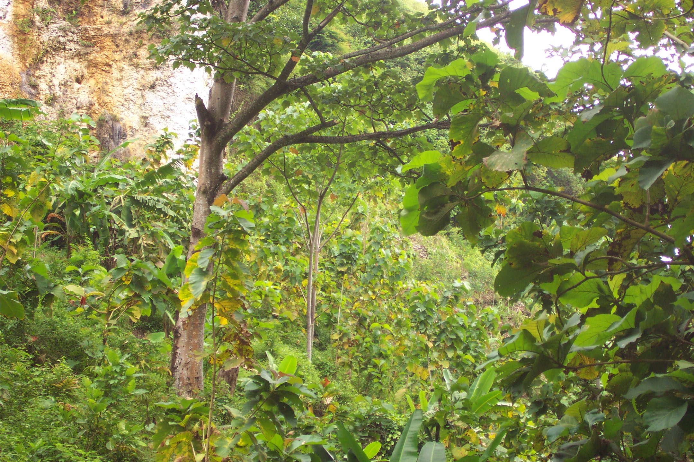  Photograph Hamilton-Smith

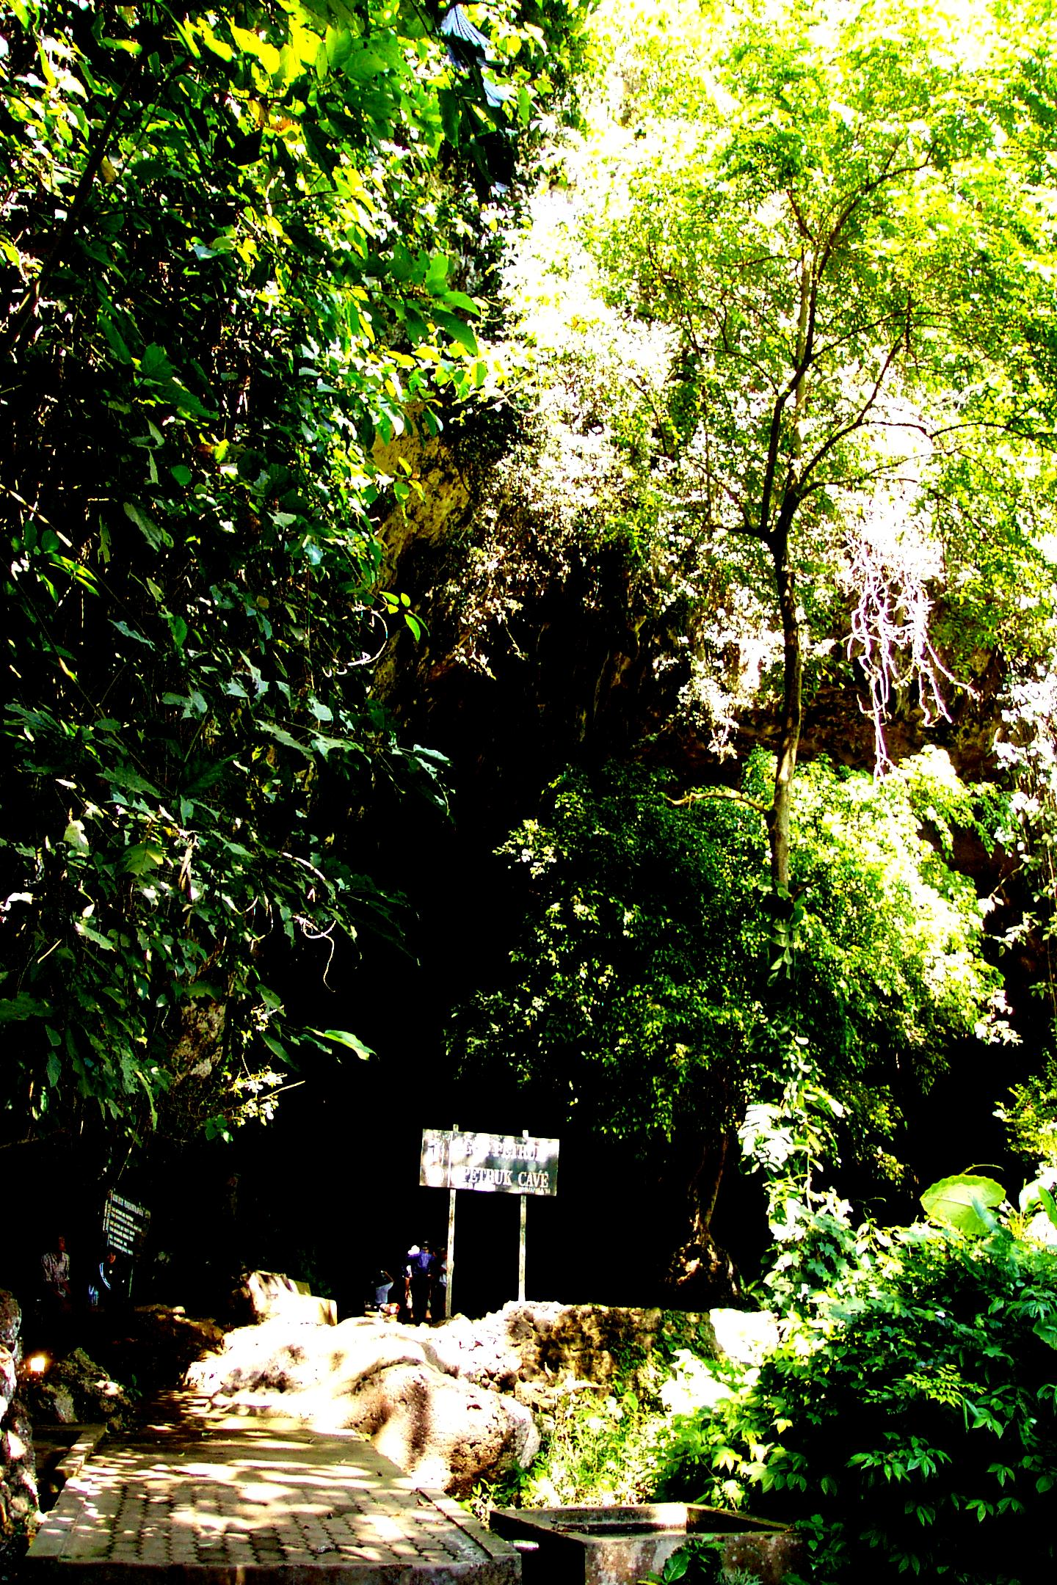  Photograph Hamilton-Smith | The entry area needs a gathering platform  and special attention to its aesthetic quality.

The view looking outwards from the entrance is spectacular | 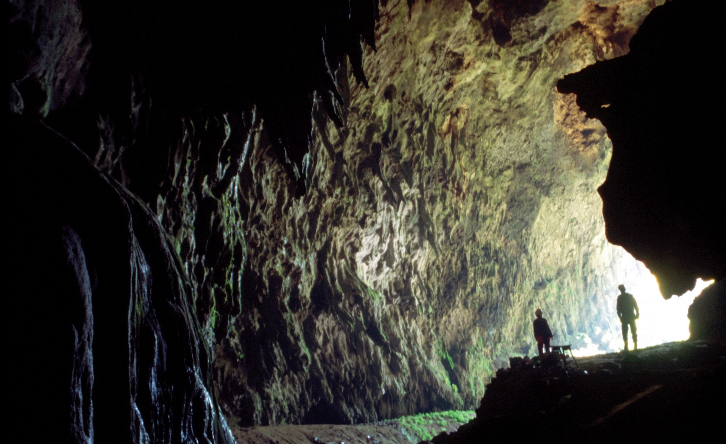  Photograph J & B Lips

8b. The Mainstream Cave Tour

An elevated boardwalk should be constructed through that part of the main passage which is open to the public. This might be built from any of

- A moisture resistant timber

The ironwood, Eusideroxylon zwageri, known as Belian Batu or Un has served well at Mulu Caves in Sarawak. Experience there shows that it checked on delivery to ensure that unscrupulous traders have not substituted other unsuitable timbers. It should, for various reasons, be kept clean of mud, leaves or moss. Forest walkways at Mulu are cleaned three times weekly, but much less frequently would suffice in the cave.

A possible substitute is to use a sound hardwood thoroughly coated after construction with Emerclad. This has a good non-slippery surface, but any breakdown in the costing will allow rot to set in.

- Good quality recycled plastic, properly tested to ensure both chemical neutrality and structural strength.

- Rust-proof metal expanded mesh. This must be rust-proof, hence stainless steel would be preferable. Neither galvanized steel, copper/brass nor aluminium should ever be used for any in-cave application.

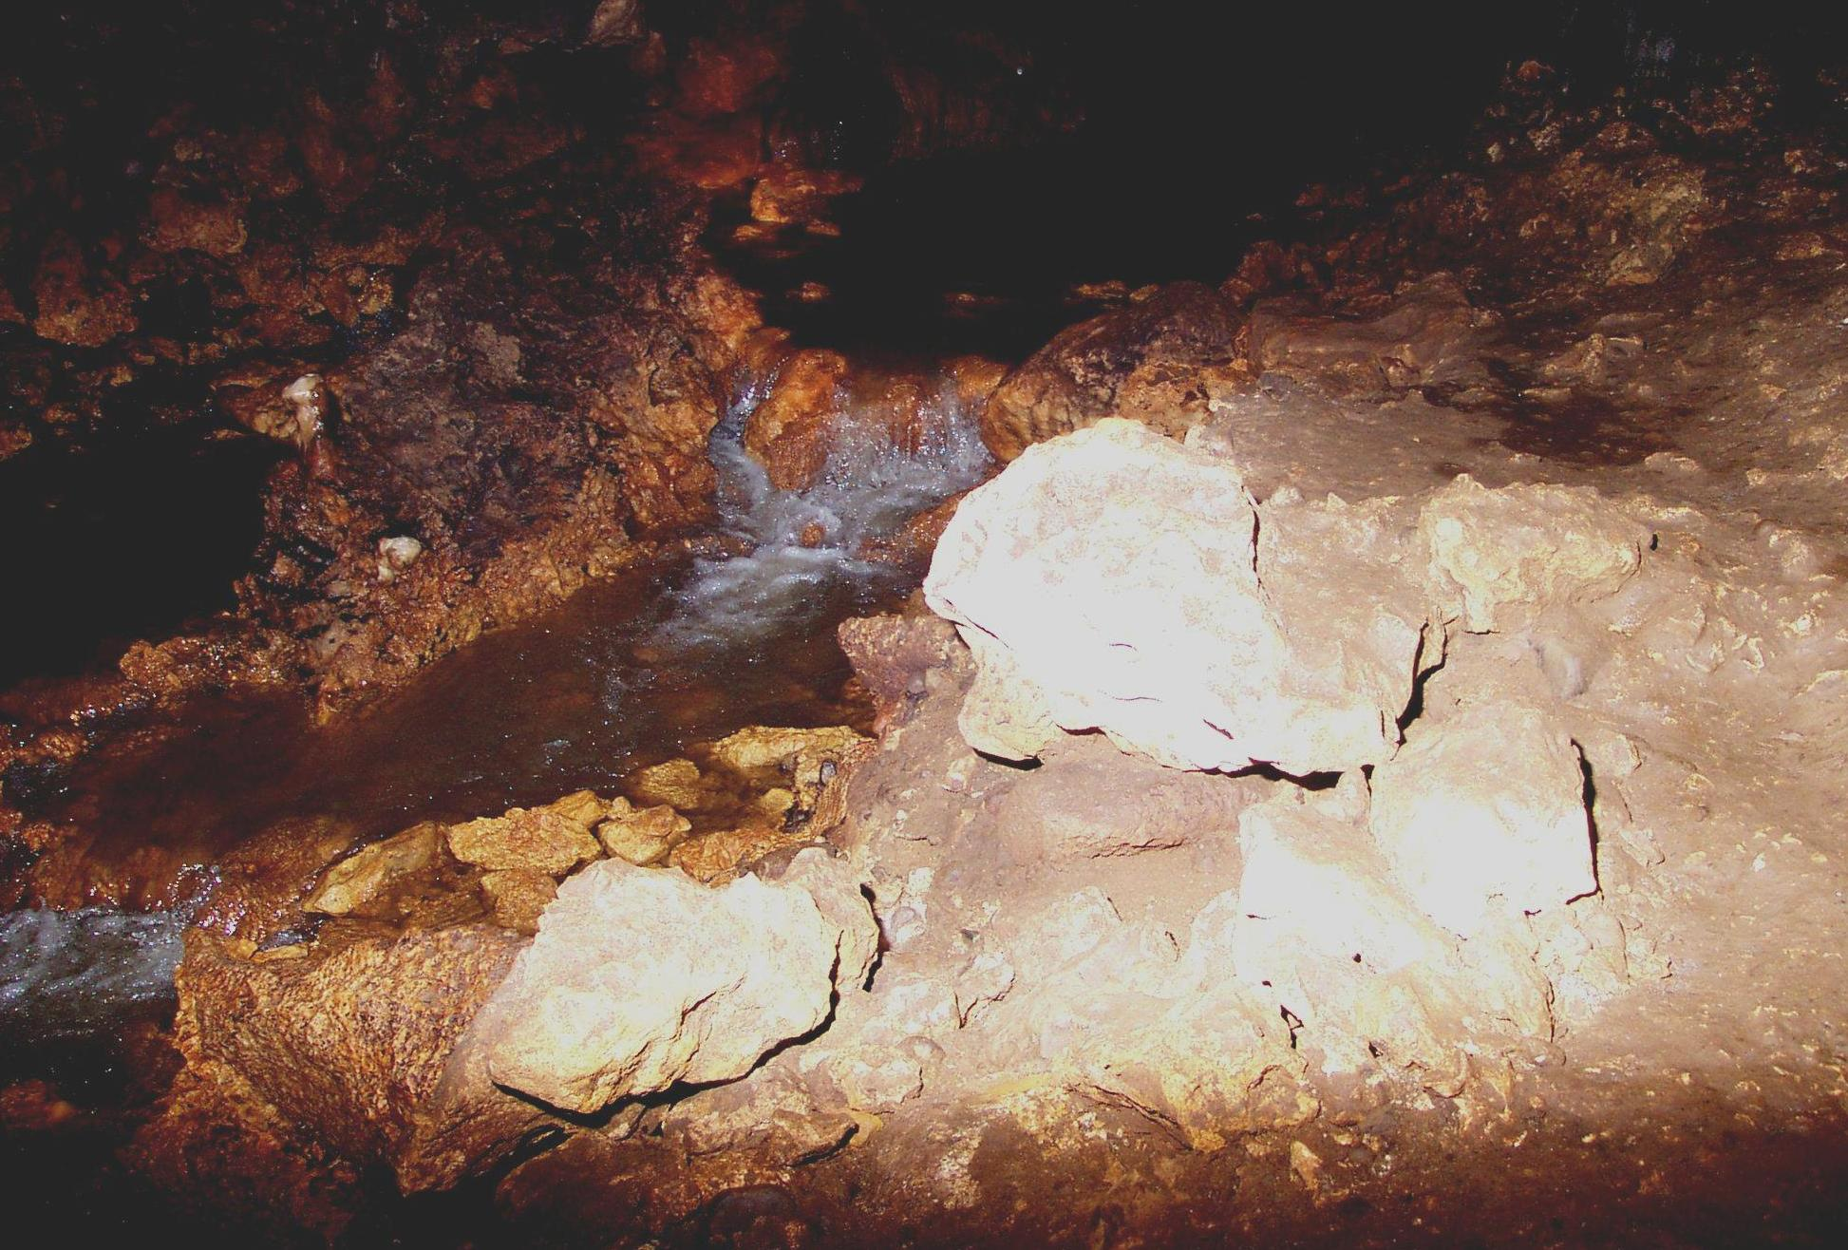  Photograph Hamilton-Smith | The boardwalk must bridge the stream wherever necessary and also avoid any need to negotiate one’s way over the rough floor surface with its rocks and boulders.

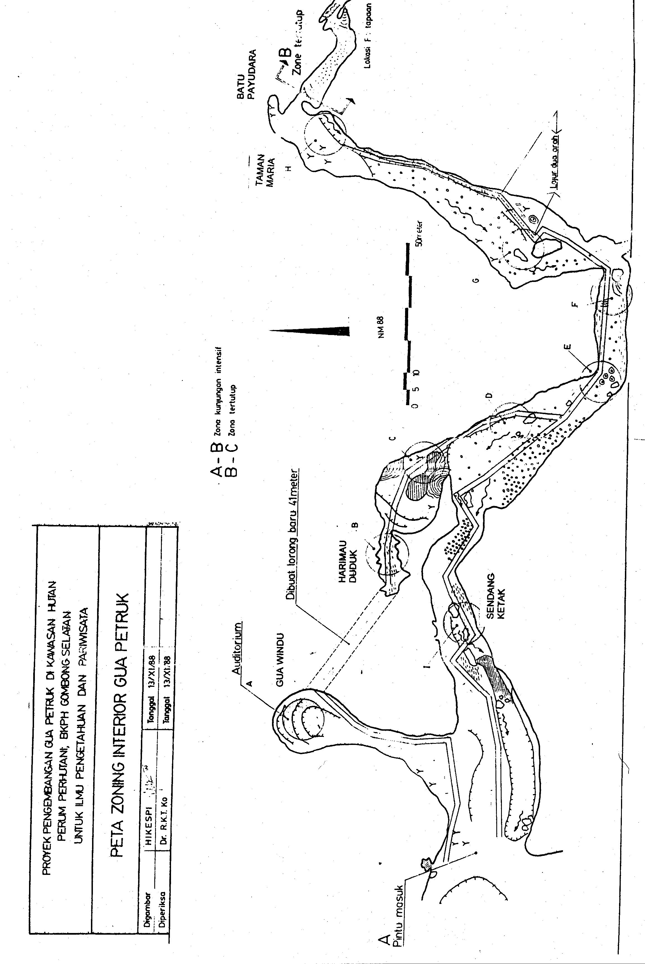

The pathway should be fully illuminated whenever the cave is open, probably using LED strips shielded from above to that the lights are not directly visible to the visitors. These should be powered with appropriate batteries to minimise the risk of lighting failure. At intervals appropriately shaped viewing platforms should be built, each to accommodate the maximum size tour group, so that a party can pause and view the site at their ease and discuss what they are seeing. Handrails might be installed at specific parts of the trail and should certainly be provided around the viewing platforms.

Party size is a vexed question, as it must strike a balance between adequate and easy communication on one hand and economic viability on the other. In Gua Petruk, fifteen people would probably be the likely maximum number. If experience shows that a larger number might be taken through and still able to communicate with the guide, then a shift might be made to a higher number.

If the site is to achieve eco-tour ideals, then each party would be guided, at least on their first tour (see below re optional tours). The guide should not deliver a monologue, but rather join in discussion with visitors about the cave. Further, each trip might be built around interests expressed by members of the party, or might follow a theme suggested by the guide. It certainly should not just offer a great number of topics or themes – this is only confusing or even annoying to visitors. Some visitors might enjoy a silent tour; others might like a tour that is fun. So each guide should develop a repertoire of up to 5 or 6 different kinds of tour that they might use, and even then, should also be ready to improvise so as to meet the interests of any specific group of visitors.

Initially, tours may only be offered in Bahasa, but guides must be helped to learn enough of one or more of the languages of international visitors so that they are able to offer tours in that language. This is absolutely vital if international visitors are to be encouraged to visit.
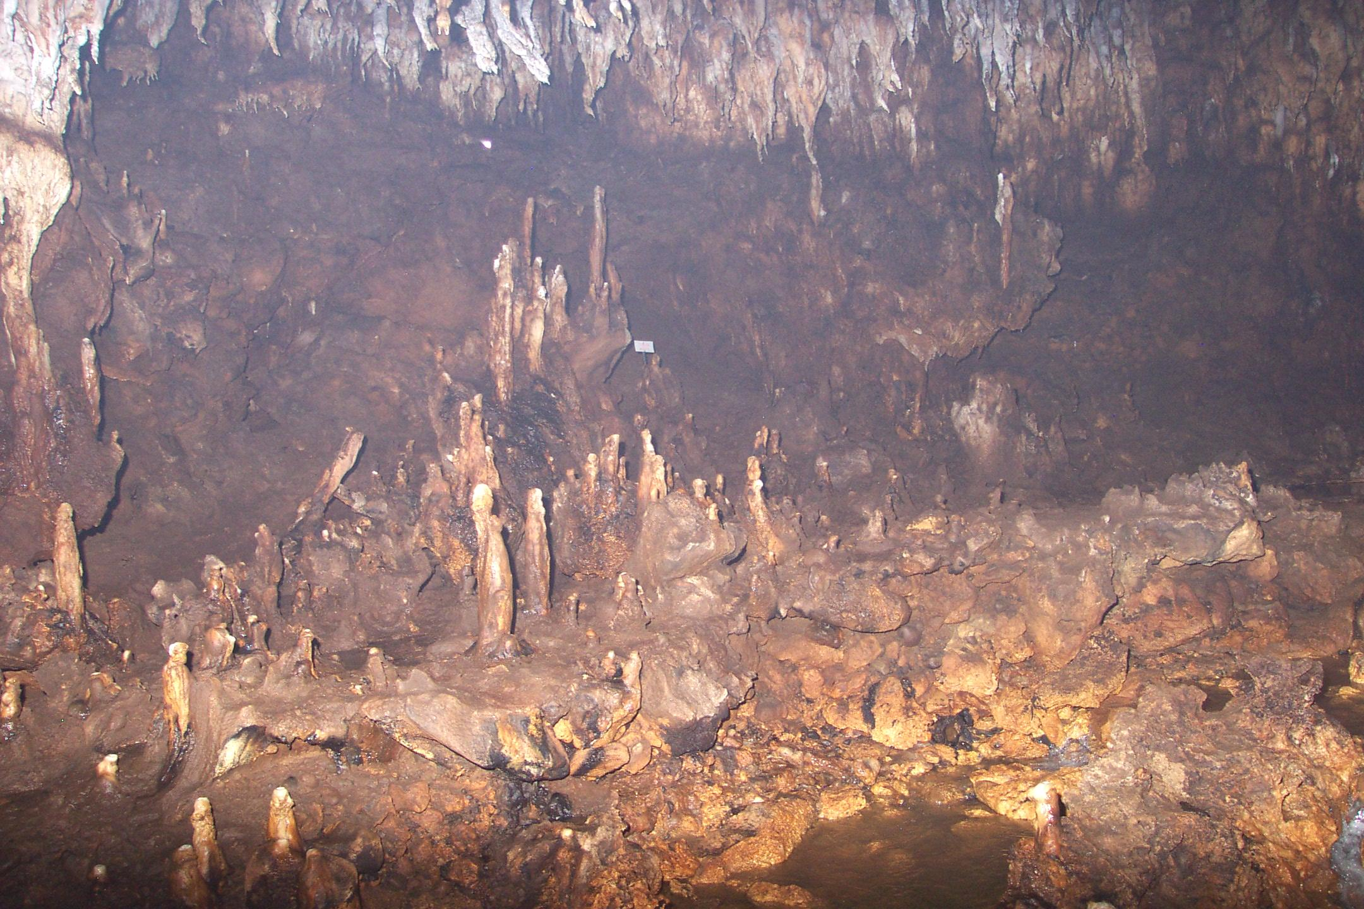  Photograph Hamilton-Smith | The stalagmite display at Taman Maria

The main route should commence on the northern side of the stream but in general follow close to the stream, crossing over when appropriate. It should run as far as Taman Maria. At this point there is the cluster of interesting stalagmites on the left, and a beautiful series of flowstone terraces on the right. On the return journey, the track should, when possible, move away from the steam and along the Northern wall, then up a flight of steps with one or more rest platforms to reach Harimau Duduk. They would then move back down the stairs and exit along the main track.

[The map that was provided to me shows a suggested tunnel cut from Harimau Dudak to Gua Windu. Although this might be a convenience for visitors, it is not appropriate in a cave with an eco-tourism focus. It would also be very costly as such a tunnel must be fitted with airtight doors at each end.]

The bats occasionally roost in the main passageway. If seen during a tour, they should not be further disturbed by shouting or by having lights directed at them.
The stream runs down over the flowstones adjacent to Taman Maria | 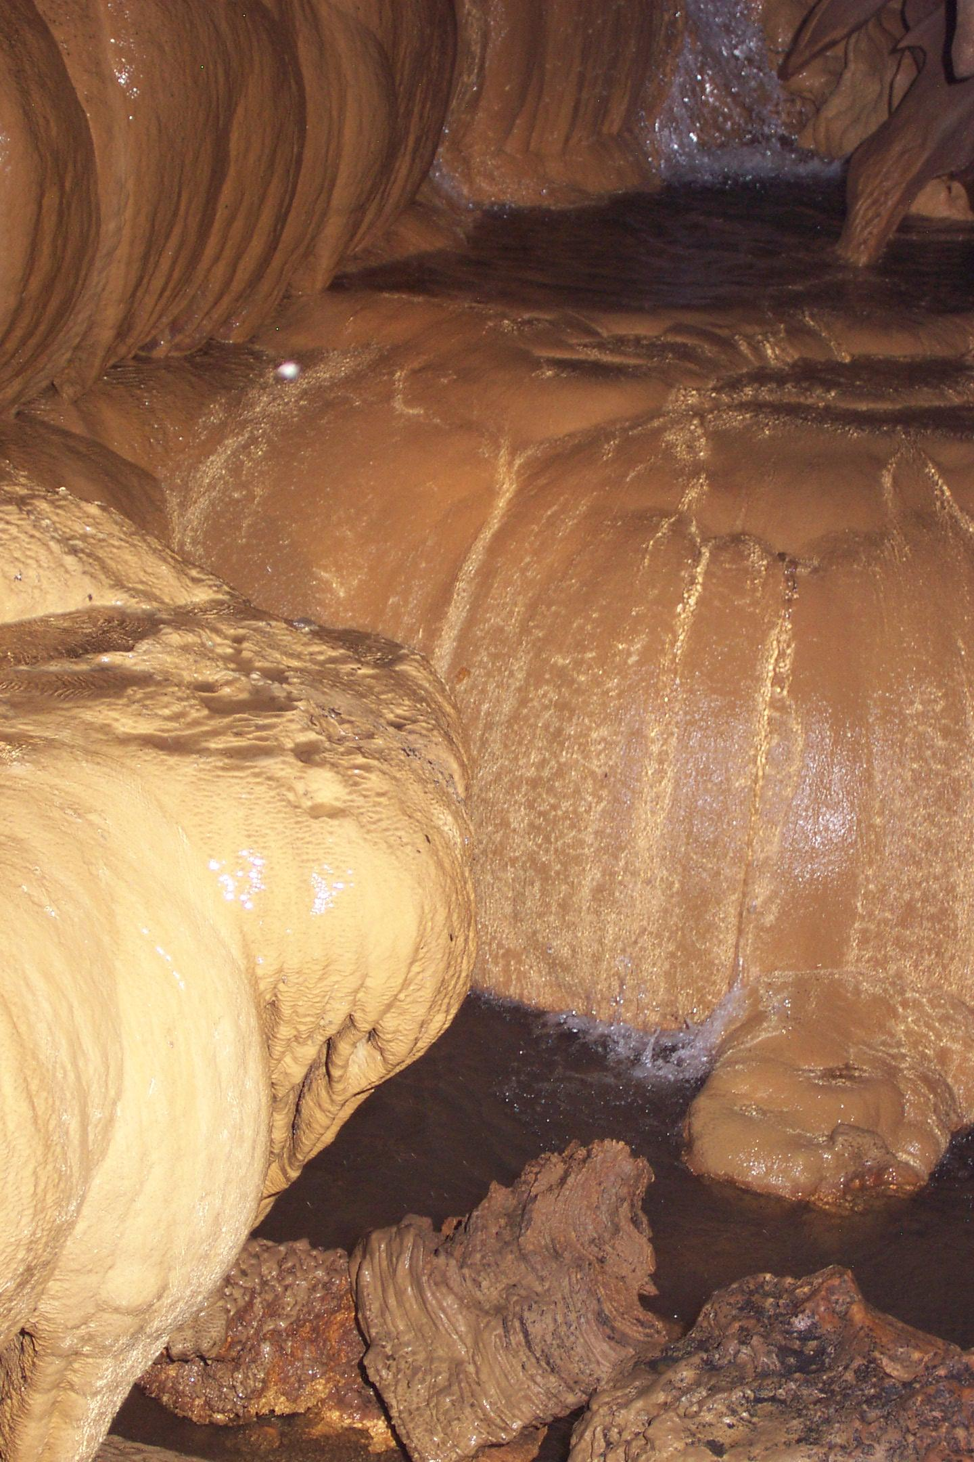  Photograph Hamilton-Smith

The stairway would be of similar construction to the pathways. The measurements of the steps should be calculated from the standard international formula and according to the gradient of the route. The total stairway might curve to fit the wall profile, but may need to take an zig-zag route to avoid excessive steepness. In either design, there probably needs to be two rest platforms (say, at 15-step intervals).

Safety of design demands that it should have easily held handrails on both sides. The steps should re regularly spaced and clearly lit. Lighting may well be recessed in the face of each riser. They must have a non-slippery surface, particularly on the front edge.

The final issue in this brief description is that of feature lighting within the cave. If funds prove to be limited, guides could use large quartz-halogen torches with rechargeable batteries to highlight cave features. However, the ideal would be to use a low-voltage fixed light system to highlight features and to have this controlled by a C-bus computerized system with a choice of programs.

Professional design and thorough field-testing of the design prior to any fixed installation is vital. The aim should be to show the key features clearly, against a dark background to maximise the aesthetic value of the cave and to maintain a sense of excitement and mystery.

8c. Optional Tours

A variety of optional tours might be offered. Those who had completed the standard tour might like to return and walk through again at their own pace, each with a hand-held light, to look at the cave in more depth, or to take photographs.

Interested and appropriate visitors might also be offered off-trail tours. They must be supplied with LED headlamps and overalls. They also need appropriate footwear and this might also be supplied. Gua Windu might well be utilised as a route for such tours, but if so, a simple path with a handrail will be necessary. In other routes, trails on floors should be marked with tape to minimise trampling, e.g., beyond Taman Maria. Again, visitors should be asked to refrain from disturbing bats.

A surface walking route to enable visitors to see other parts of the forest and hopefully the surface of the plateau might also be developed.

9. Post-tour Follow-up

Visitors should be given, or be able to purchase, mementos of their visit which will help them to remember their experience and share it with friends. These might range from single-page information sheets, each dealing one aspect of the cave, though postcards to photographic folders to booklets or ultimately, Videotapes, CD or DVD presentations.

Souvenirs should comprise items such as carvings or woven goods produced by local residents in order to maximize the direct economic benefits for the community.

If the conservation and eco-tourism ideal is to be pursued, there must be opportunities for visitors to share in the maintenance or enhancement of the cave or of the local ecology. This may be on a one-off basis associated with a single visit. But it may involve a commitment over time through a formal association of some kind

For instance, in some countries, people will join what is known as a Friends Group.
Such a group visits at regular intervals to undertake specific work projects that may range from practical tasks like forest rehabilitation or track construction through to organising special events to attract visitors. They will probably have a badge to wear and may publish a regular newsletter or some other communication.

As visitors leave, a guide or other staff member should ask if they need information about other things to see or do in Gombong; encourage them to think more about how they might best engage with nature; thank them for visiting and bid them farewell on their journey.

